**Question 1:**

SQL coding:

“

/*

* Phung Duy Luong - 12520250@gm.uit.edu.vn

*/

USE master

GO

CREATE DATABASE [BSQL_ASS2_2]

GO

USE [BSQL_ASS2_2]

”

1. Create table ‘EMPLOYEE’, SQL coding:

“

GO

CREATE TABLE [EMPLOYEE]

(

[EmpNo] int not null,

[EmpName] nvarchar(50) not null,

[BirthDay] datetime null,

[DeptNo] int not null,

[MgrNo] int not null,

[StartDate] datetime not null,

[Salary] money null,

[Level] int not null,

[Status] int not null,

[Note] nvarchar(100) null,

CONSTRAINT PK_Employee PRIMARY KEY([EmpNo]),

CONSTRAINT CK_Emp_Level CHECK([Level] >= 1 and [Level] <= 7),

CONSTRAINT CK_Emp_Status CHECK([Status] >= 0 and [Status] <= 2),

)

”

1. Create table ‘SKILL’, SQL coding:

“

GO

CREATE TABLE [SKILL]

(

[SkillNo] int not null IDENTITY(1,1),

[SkillName] nvarchar(50) not null,

[Note] nvarchar(100) null,

CONSTRAINT PK_Skill PRIMARY KEY([SkillNo]),

)

”

1. Create table ‘DEPARTMENT’, SQL coding:

“

GO

CREATE TABLE [DEPARTMENT]

(

[DeptNo] int not null IDENTITY(1,1),

[DeptName] nvarchar(50) not null,

[Note] nvarchar(100) null,

CONSTRAINT PK_Department PRIMARY KEY([DeptNo]),

)

”

1. Create table ‘EMP_SKILL’, SQL coding:

“

GO

CREATE TABLE [EMP_SKILL]

(

[SkillNo] int not null,

[EmpNo] int not null,

[SkillLevel] int not null,

[RegDate] Datetime not null,

[Description] nvarchar(100) null,

CONSTRAINT PK_EmpSkill PRIMARY KEY ([SkillNo],[EmpNo]),

CONSTRAINT FK_EmpSkill_SkillNo FOREIGN KEY([SkillNo]) REFERENCES [dbo].[SKILL]([SkillNo]),

CONSTRAINT FK_EmpSkill_EmpNo FOREIGN KEY([EmpNo]) REFERENCES [dbo].[EMPLOYEE]([EmpNo]),

CONSTRAINT CK_EmpSkill_Level CHECK([SkillLevel] >= 1 and [SkillLevel] <= 3),

)

”

Result:

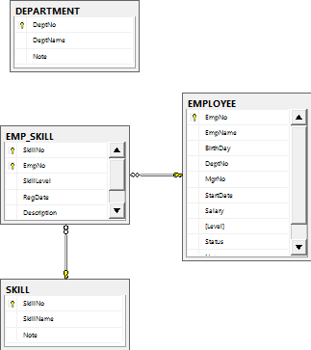

**Question 2:**

1. Add an ‘Email’ field to ‘EMPLOYEE’ table and make sure that the database will not allow the value for ‘Email’ to be inserted into a new row if that value has already been used in another row, SQL coding:

“

GO

ALTER TABLE [dbo].[EMPLOYEE] ADD [Email] nvarchar(50)

ALTER TABLE [dbo].[EMPLOYEE] ADD CONSTRAINT UNIQUE_Emp_Email UNIQUE([Email])

”

1. Modify ‘EMPLOYEE’ table to set default values to 0 of ‘MgrNo’ and ‘Status’ fields, SQL coding:

“

GO

ALTER TABLE [dbo].[EMPLOYEE] ADD CONSTRAINT DEF_Emp_MgrNo DEFAULT 0 FOR [MgrNo]

ALTER TABLE [dbo].[EMPLOYEE] ADD CONSTRAINT DEF_Emp_Status DEFAULT 0 FOR [Status]

”

Result:

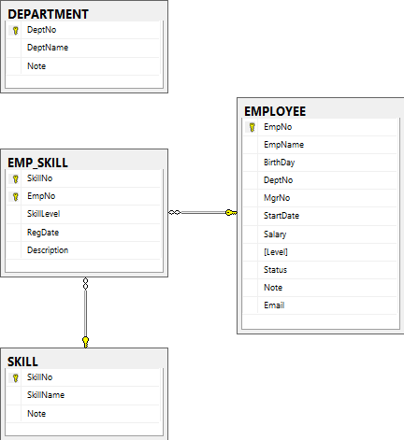

**Question 3:**

1. Add the FOREIGN KEY constrain of DeptNo field to the EMPLOYEE table that will relate the DEPARTMENT table, SQL coding:

“

GO

ALTER TABLE [dbo].[EMPLOYEE] ADD CONSTRAINT FK_Emp_DeptNo FOREIGN KEY(DeptNo) REFERENCES [dbo].[DEPARTMENT]([DeptNo])

”

1. Remove the Description field from the EMP_SKILL table, SQL coding:

“

GO

ALTER TABLE [dbo].[EMP_SKILL] DROP COLUMN [Description]

”

Result:

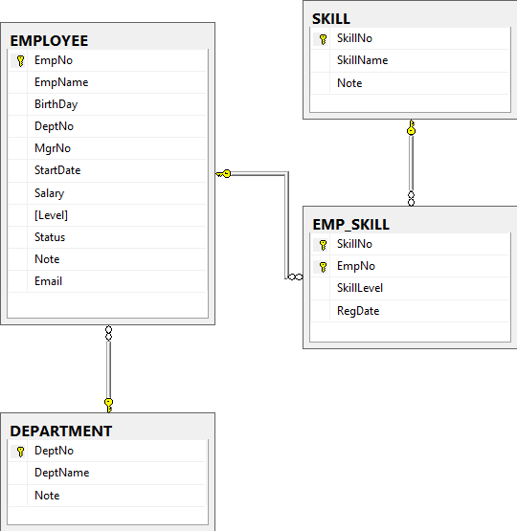

**Question 4:**

1. Add at least 5 records into each the created tables, SQL coding:

* DEPARTMENT:

“

GO

INSERT INTO [dbo].[DEPARTMENT]([DeptName],[Note])

VALUES(N'Nhân Sự','Phòng nhân sự')

INSERT INTO [dbo].[DEPARTMENT]([DeptName],[Note])

VALUES(N'Khách Hàng',N'Phòng chăm sóc khách hàng')

INSERT INTO [dbo].[DEPARTMENT]([DeptName],[Note])

VALUES(N'Kế Toán',N'Phòng kế toán')

INSERT INTO [dbo].[DEPARTMENT]([DeptName],[Note])

VALUES(N'Marketing',N'Phòng marketing')

INSERT INTO [dbo].[DEPARTMENT]([DeptName],[Note])

VALUES(N'Phát Triển Phần Mềm',N'Bộ phận phát triển phần mềm')

”

Result:

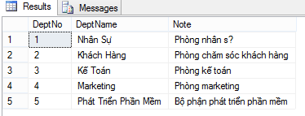

* EMPLOYEE:

“

GO

INSERT INTO [dbo].[EMPLOYEE]([EmpNo],[EmpName],[BirthDay],[DeptNo],[MgrNo],[StartDate],[Salary],[Level],[Status],[Note],[Email])

VALUES(1,N'Nguyễn Văn A','08/19/1993',1,3,'08/19/2014',10000000,5,0,N'Nhân vật hư cấu','anv@gmail.com')

INSERT INTO [dbo].[EMPLOYEE]([EmpNo],[EmpName],[BirthDay],[DeptNo],[MgrNo],[StartDate],[Salary],[Level],[Status],[Note],[Email])

VALUES(2,N'Nguyễn Văn B','08/19/1991',2,2,'08/19/2013',11000000,5,0,null,'bnv@gmail.com')

INSERT INTO [dbo].[EMPLOYEE]([EmpNo],[EmpName],[BirthDay],[DeptNo],[MgrNo],[StartDate],[Salary],[Level],[Status],[Note],[Email])

VALUES(3,N'Nguyễn Văn C','08/19/1993',3,1,'08/19/2014',25000000,5,0,N'Nhân viên xuất sắc','cnv@gmail.com')

INSERT INTO [dbo].[EMPLOYEE]([EmpNo],[EmpName],[BirthDay],[DeptNo],[MgrNo],[StartDate],[Salary],[Level],[Status],[Note],[Email])

VALUES(4,N'Nguyễn Văn D','08/19/1992',1,3,'08/19/2015',8000000,5,0,N'Sắp bị đuổi','dnv@gmail.com')

INSERT INTO [dbo].[EMPLOYEE]([EmpNo],[EmpName],[BirthDay],[DeptNo],[MgrNo],[StartDate],[Salary],[Level],[Status],[Note],[Email])

VALUES(5,N'Nguyễn Văn E','08/19/1993',2,3,'08/19/2014',14000000,5,0,N'Chuẩn bị nghỉ hưu','env@gmail.com')

”

Result:

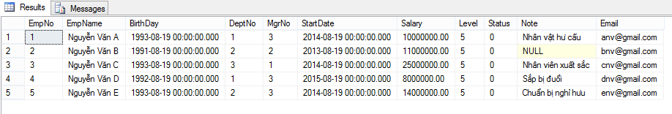

* SKILL:

“

GO

INSERT INTO [dbo].[SKILL]([SkillName],[Note])

VALUES(N'Đàm Phán',N'Thường ở bộ phận chăm sóc khách hàng')

INSERT INTO [dbo].[SKILL]([SkillName],[Note])

VALUES(N'Thiết Kế Phần Mềm',N'Thường ở bộ phận Phát triển phần mềm')

INSERT INTO [dbo].[SKILL]([SkillName],[Note])

VALUES(N'Test Software',N'Thường ở bộ phận Kiểm thử phần mềm')

INSERT INTO [dbo].[SKILL]([SkillName],[Note])

VALUES(N'Lãnh Đạo',N'Thường ở bộ phận Quản lý nhân sự')

INSERT INTO [dbo].[SKILL]([SkillName],[Note])

VALUES(N'Marketing',N'Thường ở bộ phận Marketing')

”

Result:

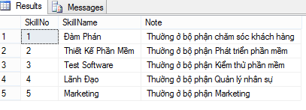

* EMP_SKILL:

“

GO

INSERT INTO [dbo].[EMP_SKILL]([SkillNo],[EmpNo],[SkillLevel],[RegDate])

VALUES(1,1,1,'08/19/2014')

INSERT INTO [dbo].[EMP_SKILL]([SkillNo],[EmpNo],[SkillLevel],[RegDate])

VALUES(4,2,2,'08/19/2014')

INSERT INTO [dbo].[EMP_SKILL]([SkillNo],[EmpNo],[SkillLevel],[RegDate])

VALUES(3,3,3,'08/19/2014')

INSERT INTO [dbo].[EMP_SKILL]([SkillNo],[EmpNo],[SkillLevel],[RegDate])

VALUES(5,4,3,'08/19/2014')

INSERT INTO [dbo].[EMP_SKILL]([SkillNo],[EmpNo],[SkillLevel],[RegDate])

VALUES(2,5,1,'08/19/2014')

”

Result:

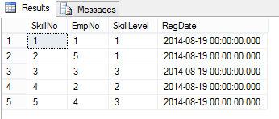

1. Create a VIEW called ‘EMPLOYEE_TRACKING’ that will appear to the user as ‘EmpNo’, ‘Emp_Name’ and ‘Level’. It has Level satisfied the criteria: Level >=3 and Level <= 5, SQL coding:

“

GO

CREATE VIEW EMPLOYEE_TRACKING

AS

SELECT [EmpNo], [EmpName], [Level]

FROM [EMPLOYEE]

WHERE [Level] >=3 and [Level] <=5

”

Result:

